«RESISTANCE A BARILLETS - STANDARD »

Vos coordonnées :
Raison sociale
Adresse
Code postal |  | Ville
Téléphone |  |  | Mail

Vous désirez Quantité :

Puissance  (W) | Tension | Lg total  (mm) | Référence | Qté
Barillet Ø 30 mm
900 | 230V mono | 270 | RSB3292
1000 | 230V mono | 270 | RSB32102
1200 | 230V mono | 270 | RSB32122
1300 | 230V mono | 320 | RSB32132
1500 | 230V mono | 320 | RSB32152
2000 | 230V mono | 560 | RSB32202
Puissance  (W) | Tension | Lg total  (mm) | Référence | Qté
Barillet Ø 46 mm
600 | 230V mono | 180 | RSB4662
800 | 230V mono | 180 | RSB4682
800 | 230V mono | 230 | RSB4682A
900 | 230V mono | 230 | RSB4692
1200 | 230V mono | 230 | RSB46122
1200 | 230V mono | 280 | RSB46122A
1200 | 230/400V TRI | 280 | RSB46123
1500 | 230/400V TRI | 330 | RSB46153
1600 | 230V mono | 330 | RSB46162
1650 | 230/400V TRI | 360 | RSB46163
1800 | 230V mono | 330 | RSB46182
1800 | 230/400V TRI | 330 | RSB46183
2000 | 230/400V TRI | 430 | RSB46203
2200 | 230V mono | 430 | RSB46222
2200 | 230/400V TRI | 430 | RSB46223
2400 | 230V mono | 430 | RSB46242
2400 | 230/400V TRI | 430 | RSB46243
2800 | 400V TRI | 430 | RSB46283
3000 | 230/400V TRI | 430 | RSB46303
3300 | 400V TRI | 510 | RSB46333
3500 | 400V TRI | 620 | RSB46353

Barillet Ø 36 mm
600 | 230V mono | 180 | RSB3662
800 | 230V mono | 260 | RSB3682
900 | 230V mono | 290 | RSB3692
1200 | 230V mono | 330 | RSB36122
1500 | 230V mono | 390 | RSB36152
1800 | 230V mono | 450 | RSB36182
2000 | 230V mono | 485 | RSB36202

Barillet Ø 50 mm
600 | 230V mono | 180 | RSB5262
900 | 230V mono | 230 | RSB5292
1200 | 230V mono | 250 | RSB52122
1200 | 230/400V TRI | 250 | RSB52123
1800 | 230V mono | 350 | RSB52182
1800 | 230/400V TRI | 350 | RSB52183
2400 | 230V mono | 430 | RSB52242
2400 | 230/400V TRI | 430 | RSB52243 | 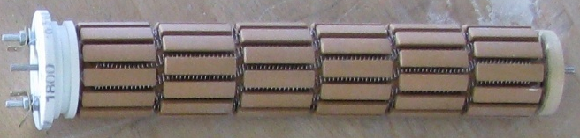
3000 | 230V mono | 430 | RSB52302 | Ø
3000 | 230v mono | 510 | RSB52302A
3000 | 230/400V TRI | 430 | RSB52303
3600 | 230/400V TRI | 530 | RSB52363 | Longueur total
4000 | 400V TRI | 720 | RSB52403
6000 | 400V TRI | 1000 | RSB52603

